**N5K Configuration Script Instructions**

***Revisions:***

*V1.0 Initial release to the general VCE D&I audience.*

*V1.1 revised for auto-save of data and error handling.*

*V1.2 normalized variables to other CRG scripts, modifies input method, added Port-channel status.*

*V1.3 Fixed issues with config dump not saving. Also capturing show interface status (SFP type)*

*V1.4 Added description for Port-Channel 1,2. Changed any VCE unknown port-channel tag and a Port-Channel with a Down state as yellow.*

**About**

These instructions are for running the N5K Configuration CRG report PowerShell Script. To run this script, PowerShell must be installed on the Windows laptop/server that the script will be run from. The Windows laptop/server must also have connectivity to the N5K switches in the Vblock for the default collection of N5K data. The system must have Excel COM object to generate the Aggregate-Eth tab of the Configuration Resource Guide default output.

**Pre-Requisites**

The script requires different pre-requisites based upon the mode being ran. By default data collection and report generation are done at the same time. For this the prerequisites are PowerShell, access to the N5K’s, proper N5k credentials, and Excel loaded. For generating a data dump, you do not require Excel to be loaded. For generating a report offline, you do not require credentials or access to the N5K’s.

**Modes of the Script**

The script has many modes; the default is to execute the PowerShell script without any arguments. This mode connects to NEXUS 5k’s grab, grab data, build excel object, display report, and exit

* Default: N5K-CRG-V1.4.ps1
* Available parameters and arguments

N5K-CRG-V1.4.ps1 <VBID> <N5k A IP address> <N5kb B IP address> <username> <password> -noexcel –noWrite -readin -Batch

Parameters:

* + <VBID>, File prefix to prepend to the saved outputs of data files and excel report.
  + <N5K A IP address or stored filename>, the ip address to access N5KA. if –readin is used then this parameter is where the stored data file is entered.
  + <N5K B IP address or stored filename>, the ip address to access N5KB. if –readin is used then this parameter is where the stored data file is entered.
  + <username>, the username to access the nexus 5k, only available for the batch mode.
  + <password>, the password to access the nexus 5K. Only available for the batch mode.

Switches:

* + –noexcel, used to not launch the com object. Used to capture data from a host accessible to the Nexus 5K but does not have excel installed, say a Jumpbox. This collects stores the data for later processing.
  + –noWrite, used to not save the data file.
  + –readin, used to create a CRG offline. This argument will cause the username and password to be ignored.
  + –Batch, used to execute the script with no user input.

**Instructions**

1. For Default behavior,

From a PowerShell CLI, run the script as follows:

**.\** N5K-CRG-V1.4.ps1

1. The script will prompt for user input and ask for confirmation. The following will be asked for:
   1. Enter the Vblock ID
   2. ip address or if “-readin” switch is set the filename of the offline dataset.
   3. Confirmation of the username
   4. Confirmation of the password.
2. The script will now collect the data, build the Excel data.

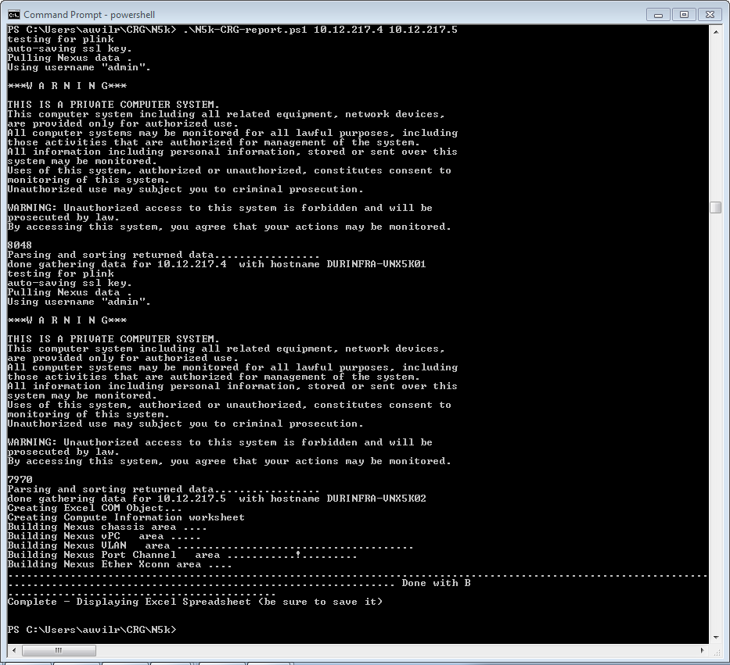

1. Upon completion the script will launch Excel reminding you to save the workbook and exit.

